LangGraph Core Concepts
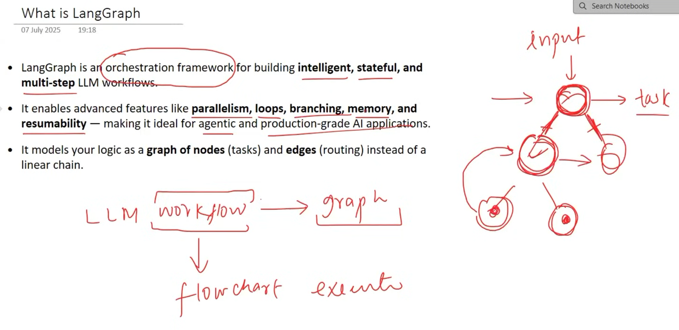
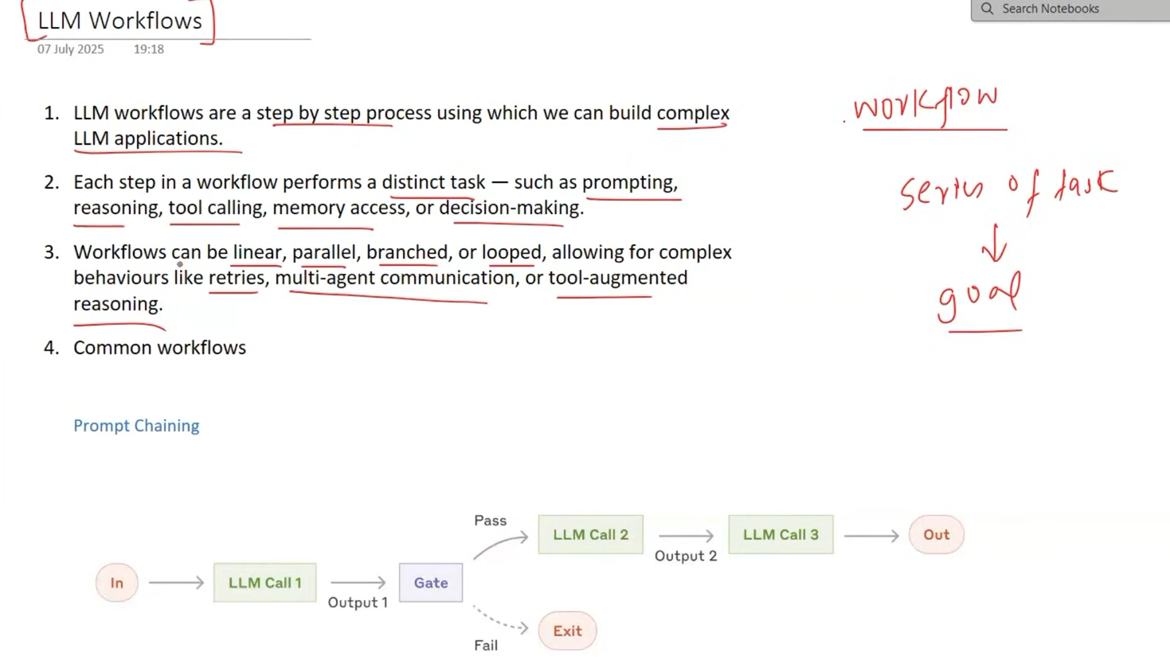
Prompt chaining means breaking one complex task into multiple smaller prompts, where the output of one prompt becomes the input of the next prompt.
Intuition
Instead of asking an LLM to do everything at once:
"Give me a joke, explain it, and translate the explanation to Hindi."
We create a chain:
Prompt 1: Generate a joke
↓
Prompt 2: Explain the joke
↓
Prompt 3: Translate the explanation to Hindi
So:
Input → Prompt 1 → Output → Prompt 2 → Output → Prompt 3 → Final Output

Routing means choosing which prompt/chain should handle an input based on its type or requirements.
Intuition: Like a receptionist directing people to the right department:
Input → Router → Appropriate Chain → Output
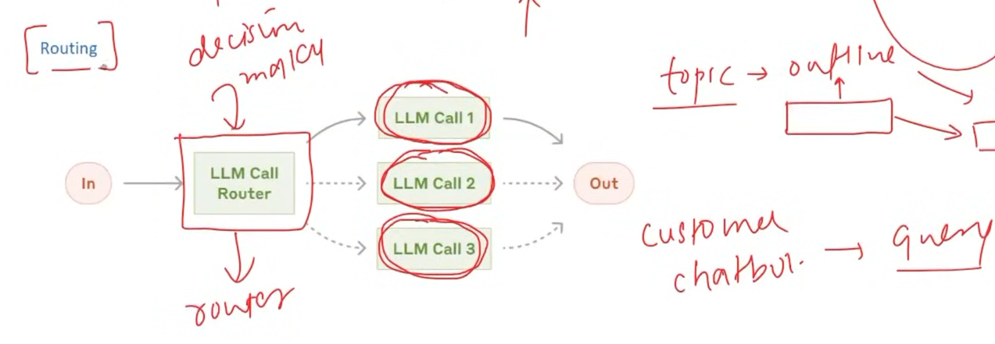

In LangGraph, parallelization means executing multiple nodes concurrently when they don't depend on each other.
Intuition: One node splits the work → multiple nodes work simultaneously → results are combined.
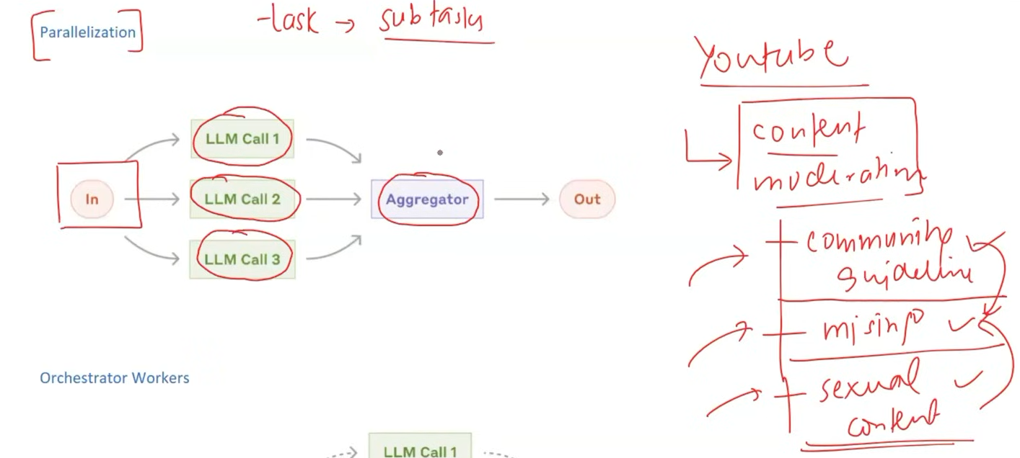

An orchestrator workflow has a central orchestrator node that decides what tasks to perform, which nodes to call, and in what order.
Intuition: Like a project manager assigning tasks to different workers.
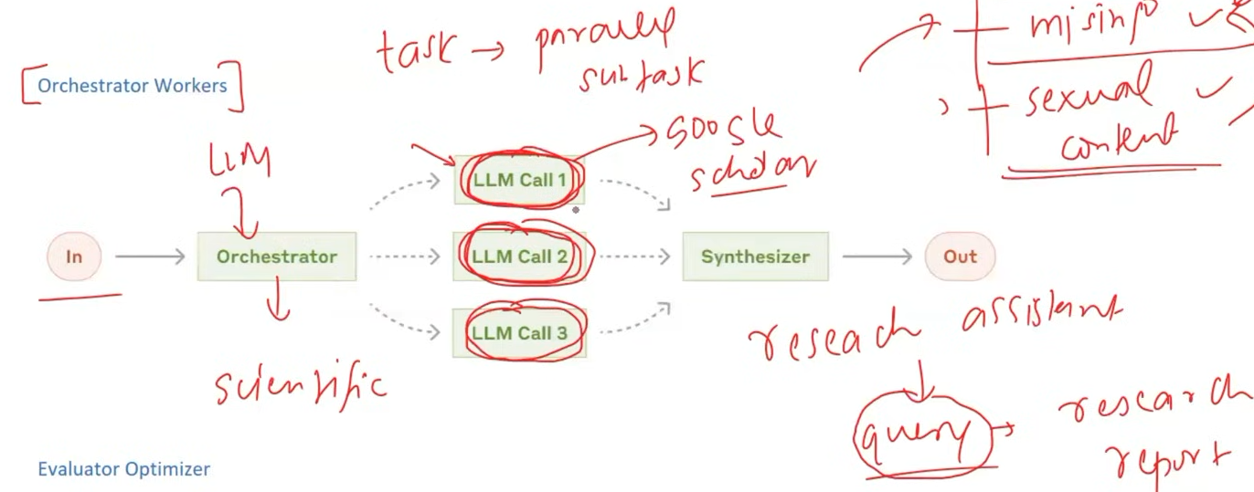

An evaluator–optimizer workflow uses one node to generate/improve an output and another to evaluate it, repeating until the output meets the required quality.
Intuition: Write → Check → Improve → Check again.
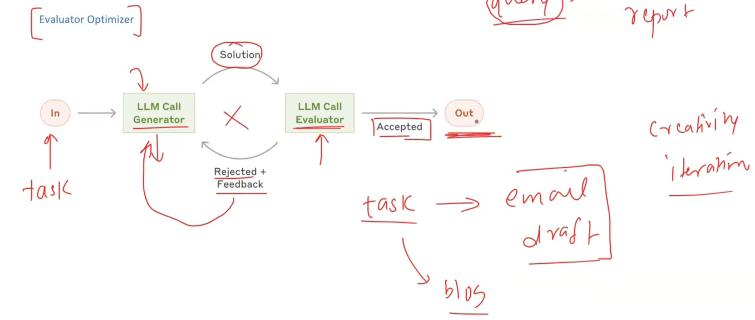

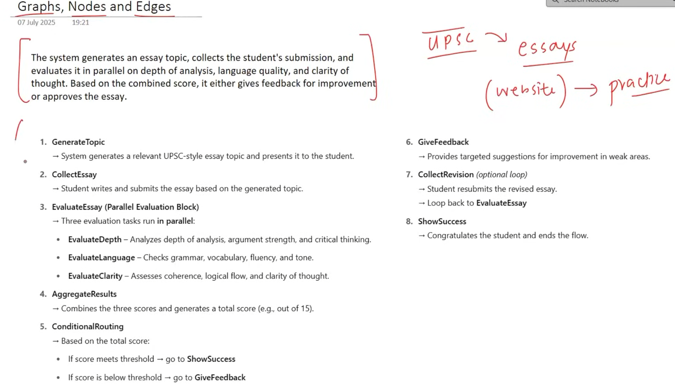

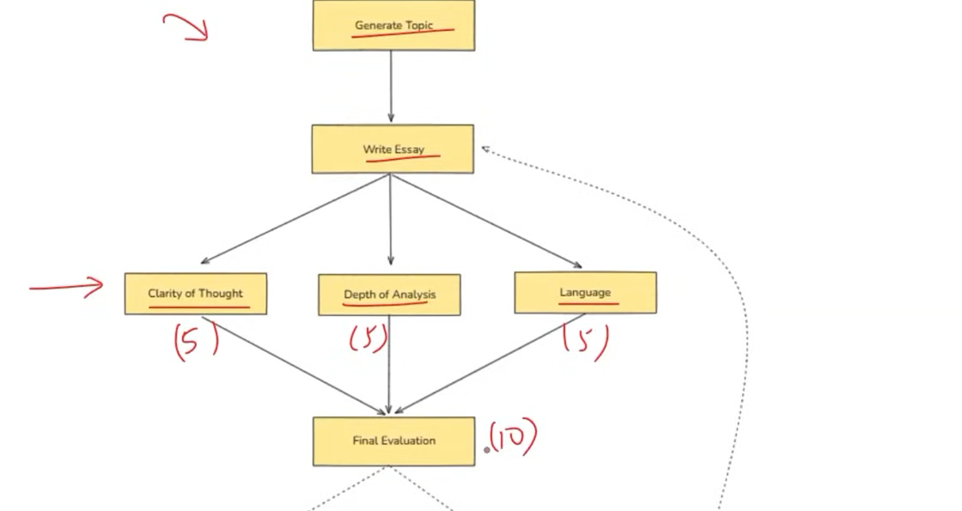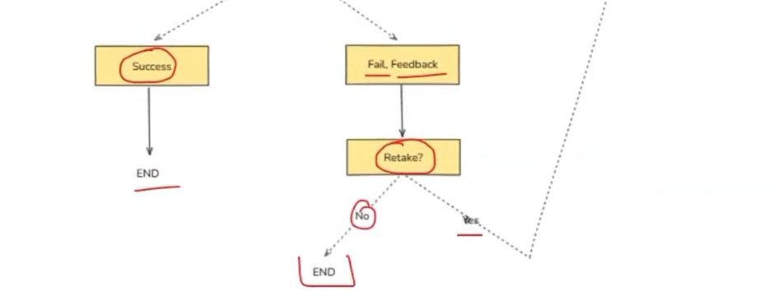
Nodes are essentially Python functions that perform specific tasks, while edges connect these nodes and determine which function executes next.
Intuition: Nodes = workers, Edges = connections telling workers who goes next.

State is a shared dictionary that stores the information being passed between nodes. Every node receives the current state as input and can update it.
Intuition: State = a shared notebook that every node can read and update.
State is a special dictionay called type-dictionary class.
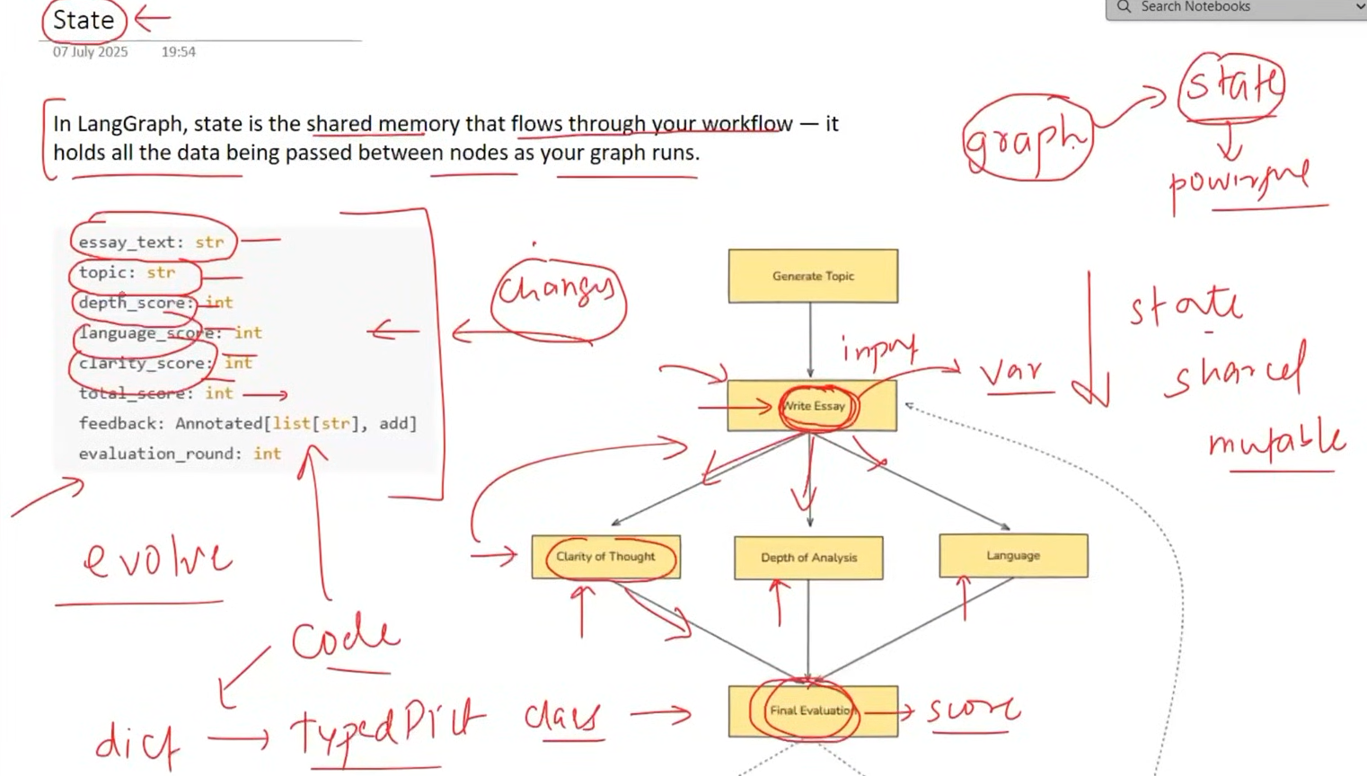

Replacing existing state data is not always a good idea, because we may lose important context that later nodes need.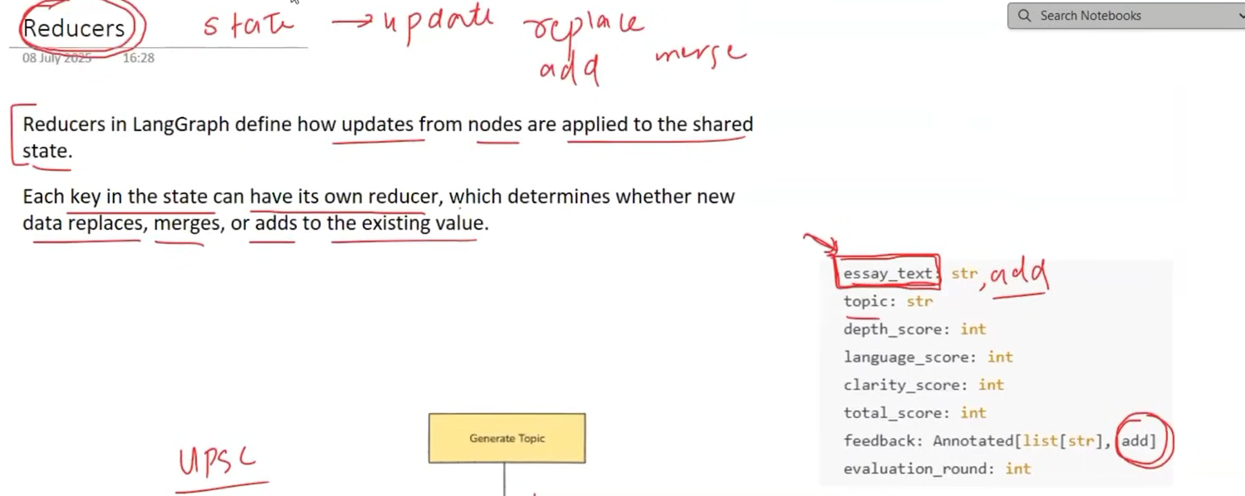

An orphan node is a node that is not connected to any other node by edges, so it is never reached during execution.
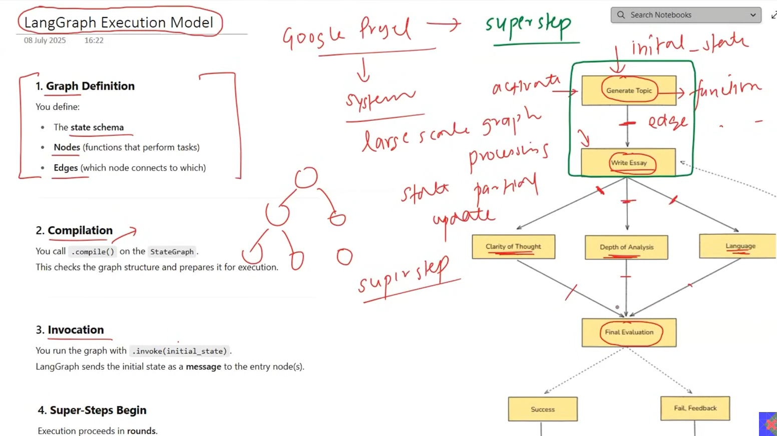
A super-step is a single execution step where multiple nodes can run simultaneously, especially when one node's output needs to be passed to multiple nodes.
Intuition: One step → multiple tasks happen together → next step.
